Round 1 Narrative CV Survey
2021 - 2022
Users’ experience and resulting changes to the template
Publication date: 30 November 2023

As part of the HRB’s commitment to creating an optimal process for capturing essential information in applications for funding, we require a narrative-style CV to be submitted in funding schemes supporting capacity building.
A further survey was conducted between 2023-2024, which further explores the experience and acceptance of using a revised narrative-like CV can be found here [link].

Round 1 survey 2021-2022: Users’ experience and resulting changes to the template
The HRB surveyed applicants, co-lead applicants and mentors, where applicable, and reviewers (peer and panel) from two funding schemes, targeting individuals from different career stages:
1. Established investigators applying to co-lead Doctoral programmes and
2. Postdoctoral researchers transitioning towards research independence.
It is important to note that the users experience was assessed between 2021 and 2022 on a previous version of the HRB narrative-style CV. The current version is in use since the end of 2022 (and took on learning from the analysis described below). The key findings are summarised below.

The researchers’ perspective (applicants and mentors)
We achieved a high response rate of 73% among lead (and co-lead) applicants and 52% among mentors with 96 responses overall.
- Overall, 77% of respondents said that the HRB narrative-based CV gives a better outline of the applicant’s research experience for the purposes of review, compared with a standard CV. However, mid-career respondents were slightly more positive (86%) compared to established researchers (72%).

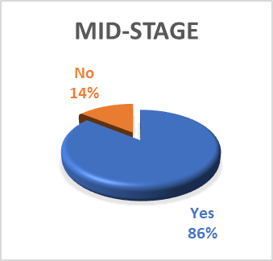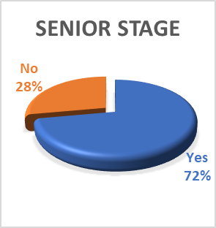

- Most respondents said that the use of the HRB narrative CV is appropriate in research career schemes with 69% rating it as good/very good, and 15% rating it as excellent. Only 16% of respondents rated it as average/poor. A higher percent (31%) of mid-career researchers thought this was excellent compared to 5% among more established investigators.
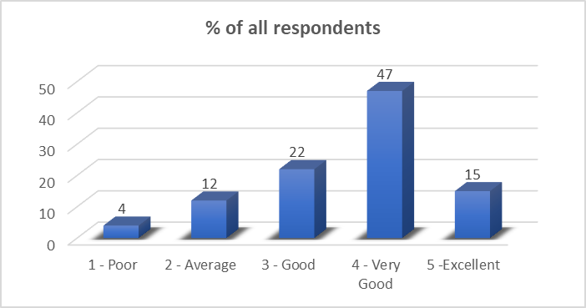

- 74% of respondents rated their experience in completing the CV as good or very good with 11% rating their experience as excellent and 14% as poor/average. More established investigators rated this question as good, followed by very good (51% and 25% respectively), while the majority of mid-career researchers showed a broadly similar rating between good and very good (37 and 34% respectively). No difference was noted in the excellence rating based on r career stage, with 11% of mid-career researchers rating it as excellent and 12% of more established researchers.

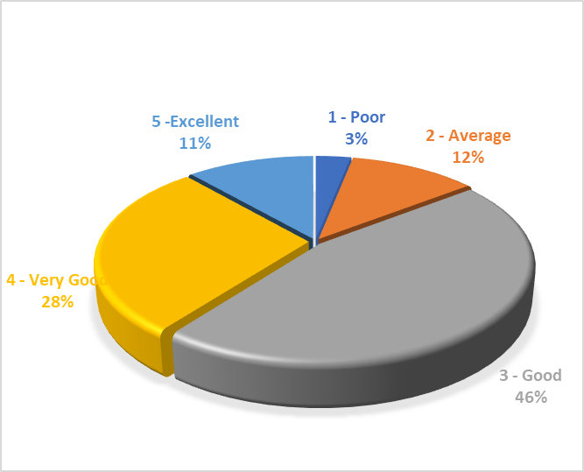

- Overall, 82% of respondents (comprising 89% of mid-career researchers and 79% of established researchers) said they would like us to consider using a similar narrative-like CV in other HRB schemes, such as the investigator-led schemes.
Other key points of feedback included:
- While the majority of respondents added positive comments about the use of such a CV, many noted that it might be too short, and they might need less restrictions on word count.
- Many respondents expressed a need to receive training and have CV examples for guidance.
- There was a suggestion to produce some case studies from review panels to understand what they think about the HRB narrative-like CV and how they use it.
- Respondents welcomed the statement in the CV that not all individuals need to demonstrate contributions in all sections of the CV.
- Some highlighted the challenge or the mismatch between what is requested in these types of CV and the more traditional metrics still used in institutions, such as Journal Impact Factors, when evaluating suitability for promotion or other career development opportunities. This can have the negative effect of discouraging researchers from disseminating their work in different formats such as research reports or public events, as these are not ‘counted’ by their institutions.
- Respondents noted that defining societal benefits and attention to measuring policy input would be also helpful.

The reviewers’ perspective
The response rate among reviewers, which included peer-reviewers and panel members, was 74% and 35 responses were received.
- 17% of reviewers were not familiar with the DORA declaration and its principles, 40% said they are familiar and 43% said they are somewhat familiar, but they are not sure how to apply the principles in funding decisions.
- 69% of reviewers responded that the information requested in the CV format comprehensively highlighted the value, quality and potential impact of the researchers' outputs (in terms of impact on the research field and/or on policy and practice) and their suitability to their role in this funding scheme while 31% reported that that the CV did this in a somewhat comprehensive manner.
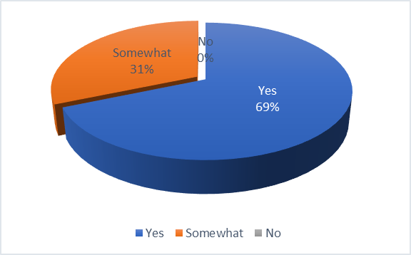

- 80% of reviewers reported that they took the different types of outputs into consideration in addition to peer-reviewed articles.
- 77% of reviewers rated the assessment of the CV as good or very good with the remainder rating it as excellent (6%), poor (6%) or average (11%).

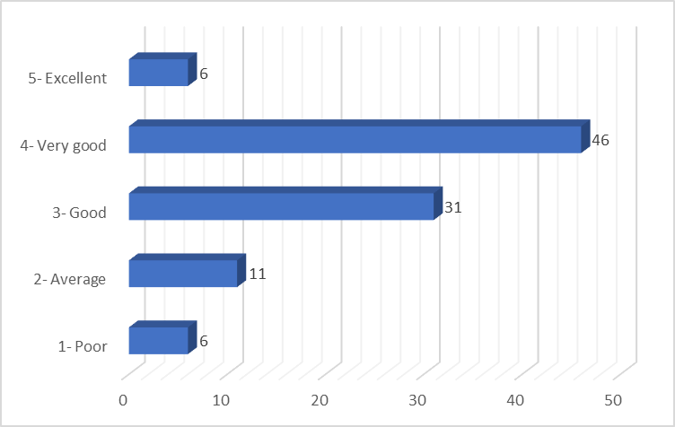

- 77% of reviewers rated the HRB narrative-based CV as more effective than more traditional CVs.
- 65% of reviewers rated the flow of the questions in the CV as being good or very good and 25% thought it was excellent. Only 8.5% of respondents thought it was average.
- 69% of reviewers said the information provided in the guidance notes and the assessment guidelines on the DORA declaration and how the HRB is implementing the principles, were very helpful while 31% thought they were somewhat useful.

Other key comments from reviewers included:
- The narrative CV format poses a number of challenges including (1) wide range of writing styles; (2) larger amount of data/information to analyse and assess; (3) subjectivity of these CVs. A potential solution proposed was ensuring a good combination/balance between lists and narrative (HRB approach) and a clarity of what to look for.
- Notwithstanding most reviewers acknowledged that the narrative like CV may provide a more holistic view of a researcher’s track record, some also stated that they still primarily used the list of peer-reviewed publications to assess the track record and other types of research outputs weighted less.
- Generally, reviewers reported that the amount of information requested from co-applicants should be more succinct and they would not need the same CV structure as the lead applicant.
- For schemes which are open to a broad range of disciplines there may be extra challenges as expectations of individuals from different disciplines can be quite different. For example, a laboratory based biomedical scientist will have a different portfolio to an experienced physiotherapist.
- The applicant’s own assessment of their career to date provides additional insight to reviewers, which was particularly useful if they did not know the research field well. However, and in some instances, applicants were not able to recognise and/or explain well their impact.

Based on all of the above feedback, the HRB made the following decisions or changes:
- Although the main questions of the CV have not substantially changed, the structure of the HRB narrative style CV is now better aligned to the Royal Society Resume for Researchers.
- This CV is used for Lead Applicants and Mentors, where relevant, in applications for HRB schemes supporting people.
- The CV for Co-applicants is now shorter, more aligned to most of the HRB funding schemes which include information that is critical for the reviewers to assess their expertise and their role in a team (e.g. researcher vs PPI contributor vs knowledge user) in the application.
- The guidance for applicants has been improved highlighting the purpose of the HRB narrative-style CV, how it will be assessed, and the flexibility of the different modules depending on career stage.
- A new webpage has been created on the HRB website, which also has a CV template available for download.
- The guidance for reviewers has been improved highlighting the purpose of the HRB narrative-style CV, how to assess the information provided to support and inform decision making appropriately, and the importance of complementarity between qualitative and quantitative metrics. HRB staff would intervene in instances where references to proxy metrics are made during the Panel discussions.
- The HRB decided not to provide exemplar CVs to guide applicants on the basis that the CV should be unique to the individual completing it and to the funding opportunity they are applying to or are supporting (mentors).

ENDS

