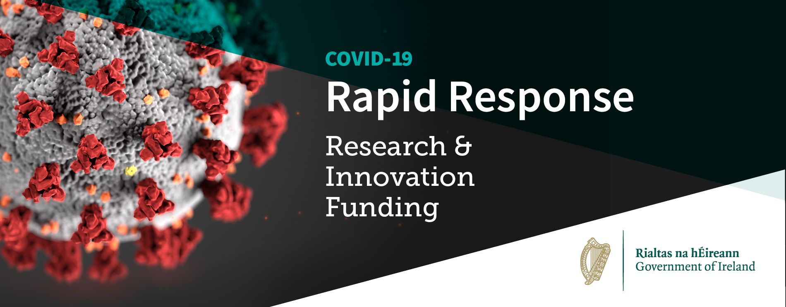
The Government’s main research and innovation agencies* have developed a coordinated Rapid Response Research and Innovation programme to help mitigate and manage the COVID-19 pandemic by unlocking the potential of Irish based researchers and innovators to join the global efforts.
The coordinated response is comprised of two complementary strands.
- The first focus area targets medical countermeasures, health service readiness, and social and policy countermeasures to COVID-19. This is led by the *Health Research Board and the Irish Research Council.
- The second focus area is an agile and adaptive funding scheme aimed at combining the capabilities of industry and academia in the development of innovative solutions that can have a rapid demonstrable impact on the current COVID-19 crisis in Ireland. This is led by *Science Foundation Ireland, Enterprise Ireland and IDA Ireland.
A total of 26 projects have now been selected by international peer review panels and will commence shortly. These are listed below.

List of successful Health Research Board-Irish Research Council projects

- Dr Gerard Molloy, NUIG; Optimising Covid-19 social distancing communications: Identifying and addressing psychosocial determinants of social distancing during the Covid-19 pandemic
Quote from Dr Molloy
‘Great progress has been made through social distancing to reduce Covid-19, however initial evidence shows maintaining this distancing has been very challenging, particularly for those facing difficult personal, social and working conditions. Our research will help us to understand what helps people achieve the required level of distancing and how we communicate about the need for further measures, especially as we relax restrictions’. €148,745

- Professor John Lambert, UCD: COVID19: The North Dublin Cohort Study
Quote from Prof Lambert
‘We don’t know if survivors of COVID-19 will have long-term complications in terms of quality of life or possible long-standing damage to the heart, lungs, and brain, which are targeted by this virus. Our follow up study with these patients will ensure they are carefully monitored and provided with appropriate treatment if necessary’. €199,098

- Professor Catherine Comiskey, TCD; Using a back-calculation model to estimate the scale of asymptomatic Covid-19 prevalence by age and determine the critical threshold of available susceptible persons within the community.
Quote from Prof Comiskey
‘Our research will provide an estimate of the number of people who may have had COVID-19 and do not know they have had it. These are called the asymptomatic cases. Knowing how many people had COVID-19 and their ages will help policy makers make safer decisions about reopening our communities and hopefully help prevent a second wave’. €96,340

- Professor Alice Coffey, UL: A Rapid Resource Repository for Health Professionals (RRR-HP): An online and social media individualised support intervention for return to practice, reassigned and new to practice.
Quote from Prof Coffey
‘We believe that our individualised support will have practical and demonstrable impact on nursing and allied health professional’s confidence in commencing, returning to practice or moving to new areas of practice and will be of benefit to professional bodies during the COVID-19 crisis and beyond’. €199,647

- Professor Rose Anne Kenny, TCD; Altered lives in a time of crisis: Preparing for recovery from the impact of the COVID-19 pandemic on the lives of older adults
Quotes from Prof Kenny
‘Because TILDA has comprehensive data collected at regular periods for the past 10 years we can explore how immune profiles and other biological and social factors change over time and which changes enhance an individual’s vulnerability to infection from COVID-19’.
‘The measures which have been introduced as a result of COVID-19 have particularly impacted on the lives of people over 70. TILDA researchers will also look at the impact of these policies on mental and physical health and hear the voice and views of those most affected. This is important if we are to understand and manage the collateral damage from COVID-19 on this vulnerable group’. €175,322

- Professor Brian McGuire, NUIG; Identifying mental health needs and best practice for psychological support in frontline healthcare workers during and after the COVID-19 outbreak and in future pandemics.
Quote from Prof McGuire
‘Those working at the frontline of COVID-19 medical care may be experiencing enormous stress - it's vital that we understand their experiences so we can provide suitable and effective psychological support’. €187,254

- Professor Catherine Darker, TCD; Creating an evidence-based toolbox for targeted public health interventions during COVID-19: a cross-border analysis to disentangle psychological, behavioural, media and governmental responses
Quote from Prof Darker
‘On the island of Ireland there two very different approaches to dealing with COVID-19. Our research will explore the implications of different measures and messaging across these two jurisdictions on two similar populations. Our aim is to create a public health toolbox that will guide decision makers in their approach to further waves of COVID-19 or for future epidemics’. €191,116

- Professor Donal Fortune. UL; An investigation of psychological responses to COVID-19 in health care workers during the delay and mitigation phase of disease management: longitudinal and nested qualitative study.
Quote from Prof Fortune
A lot is expected of our frontline heroes during COVID 19. This UL project will look at how staff are responding psychologically and establish what helps them cope and how they are responding to this unique work situation. We’ll look at people at 3, 6 and 12 months to understand what needs to be in place to best support staff in the medium and longer term. €175,013

- Dr Sinéad Smyth, DCU; Autism specific Transition RESources: a response to the COVID-19 related restrictions (TRes)
Quote from Dr Smyth
‘COVID-19 related closures and restrictions on movement have wide ranging impacts and adapting can be difficult especially for children and young people with Autism. We will be identifying the challenges and working with those affected to develop a transition guide for parents and educators preparing children and young people with Autism to resume regular daily routines when restrictions are relaxed’. €123,370

- Dr Katarzyna Whysall, NUIG; Improving long-term patient recovery and reducing disability after COVID-19 critical illness using microRNA-based approaches
Quote from Dr Whysall
‘Covid-19 is disproportionately affecting middle aged and older adults. There is little data about how to manage these patients, particularly in the post-acute recovery phase commonly associated with frailty and muscle wasting. This study looks at how small molecules, called microRNAs, can regulate muscle health and influence recovery to help identify and develop personalised treatments for people with critical illness, such as COVID-19’. €199,621

- Professor Mark Little, TCD; Defining the disease course and immune profile of COVID-19 in the immunosuppressed patient (DeCOmPRESS study)
Quote from Prof Little
‘The DECOMPRESS project will determine the outcome of patients taking immunosuppressive medication who contract COVID 19. This will allow us to target accurate advice regarding cocooning to these patients, and to inform development of new therapies and biomarkers’. €199,908

- Professor James O'Donnell, RCSI; Irish COVID-19 Vasculopathy Study (iCVS)
Quote from Prof O Donnell
‘Our recent work shows blood clotting happens in patients with severe COVID-19 infection leading to more deaths. Patients with higher levels of blood clotting were also more likely to require ICU admission. We want to understand why these micro-clots are being formed in the lungs so that more effective treatments for patients with severe COVID-19 can be developed’. €199,036

- Dr Virginie Gautier, UCD; Screening for antiviral compounds active against COVID-19
Quote from Dr Gautier
‘UCD CEPHR is focused on accelerating the development of COVID-19 treatments, we have mobilised our collaborators, resources and expertise to deliver a full COVID-19 antiviral pipeline. Our goal is to identify effective antiviral drugs to be included as part of new therapeutic interventions to reduce COVID-19 disease burden’. €190,237

- Professor Orla Hardiman, TCD; Using telehealth to enhance management of vulnerable groups during the COVID-19 pandemic
‘COVID-19 has focussed minds on how to enhance the delivery of care while minimising risk and inconvenience for patients and their families. This project will fast track technologies to provide virtual support for multidisciplinary care for those with Motor Neurone Disease and Frontotemporal dementia that we can also embed in the future care’. €199,965

- Dr Christine Linehan, UCD; Impact of COVID-19 on Individuals with Intellectual and Developmental Disabilities and Caregivers
Quote from Dr Linehan
‘People with intellectual disabilities face specific disadvantage during the pandemic; symptoms may go unnoticed, treatment may be withheld, social distancing measures may result in behaviours that challenge. Our survey aims to capture people’s experience so we can use findings to develop policy and practice guidelines for this population’. €62,858

- Dr Emma Nicholson and Dr Thérѐse McDonnell, UCD; CUPID COVID-19: Paediatric emergency department attendance during COVID-19
Quote from Dr Emma Nicholson and Dr Therese McDonnell
‘The demands of COVID 19 on the health system, coupled with people’s reluctance to bring young kids to the Emergency Department could impact care. CUPID COVID-19 will help identify the consequences of service changes and understand which patients are at high risk and what their needs are’. €107,015

- Dr Siobhan Masterson, NUIG; Rapid response and learning for later: establishing high quality information networks and evaluation frameworks for the National Ambulance Service response to COVID-19
Quote from Dr Masterson
‘Our research aims to establish local and international information networks and to create evaluation tools that ensure the National Ambulance Service is well equipped now and for any subsequent pandemics. We believe these networks and will be useful to ambulance services internationally and contribute to the global pandemic response’. €109,188

- Dr Nollaig Bourke, TCD; SABS-TILDA: COVID19 specific AntiBodieS in The Irish LongituDinal Study on Ageing (TILDA): an opportunity to assess COVID-19 rates and phenotypes in older adults in Ireland.
Quote from Dr Bourke
‘We want to learn the ‘who’ gets COVID19 and ‘why’ among older people in Ireland. We’ll investigate who was infected using the Irish Longitudinal Study on Ageing (TILDA) by measuring virus specific antibody levels and explore what risk factors are associated with disease, including analysis of how the immune system is activated in these people’. €199,875

- Dr Aaron Golden, NUIG; Expediting the diagnosis of COVID-19 in a clinical setting using AI enabled analysis of CT scans
Quote from Dr Golden
‘COVID-19 associated pneumonia is evident in chest CT scans but distinguishing COVID disease from more common lung disorders is challenging. Our AI enabled imaging system will expedite screening & support radiology teams in identifying those patients needing immediate attention’. €83,690

- Professor Ivan Perry, UCC; COVID-19: Estimating the burden of symptomatic disease in the community and the impact of public health measures on physical, mental and social wellbeing
Quote from Prof Perry
‘We hope that this project will give us a better understanding of both the underlying trends in the burden of symptomatic and asymptomatic Covid-19 infection in the community and the impact of physical distancing and related public health measures on our physical, mental, psychological and social wellbeing’. €199,945

- Professor Cathal O'Donoghue, NUIG; Modelling Real Time Population Wide Impacts of COVID-19
Quote from Prof O Donoghue
‘The response to the COVID-19 virus has had significant implications on many aspects of life, health, economic and social and has been highly asymmetric with different groups affected in different ways. The aim of this project is to develop a mechanism to delivery real-time analysis of these implications across the income distribution to facilitate policy making’. €38,310

List of successful Science Foundations Ireland-IDA Ireland -Enterprise Ireland projects

- Prof Paul Cotter ; Irish Coronavirus Sequencing Consortium, Teagasc / APC €378,716

- Prof Martin O’Halloran; INSPIRE: Facilitating Non-Invasive Ventilation (NIV) during the COVID-19 Crisis, NUIG, €205,667

- Prof Gil Lee, Prof Virginie Gautier, Prof Patrick Mallon; Critical Reagent Production Addressing Supply Chain Risk for COVID-19 Diagnostics, UCD €540,263

- Prof Tim McCarthy; Data Platform for Emergency Response Management (DPERM), Maynooth University €402,323

- Dr Ignacio Martin-Loeches; Prognostic indicators of critically ill patients with COVID-19: Impact on early immunology and survival, TCD €192,566

