

**Privacy Notice**



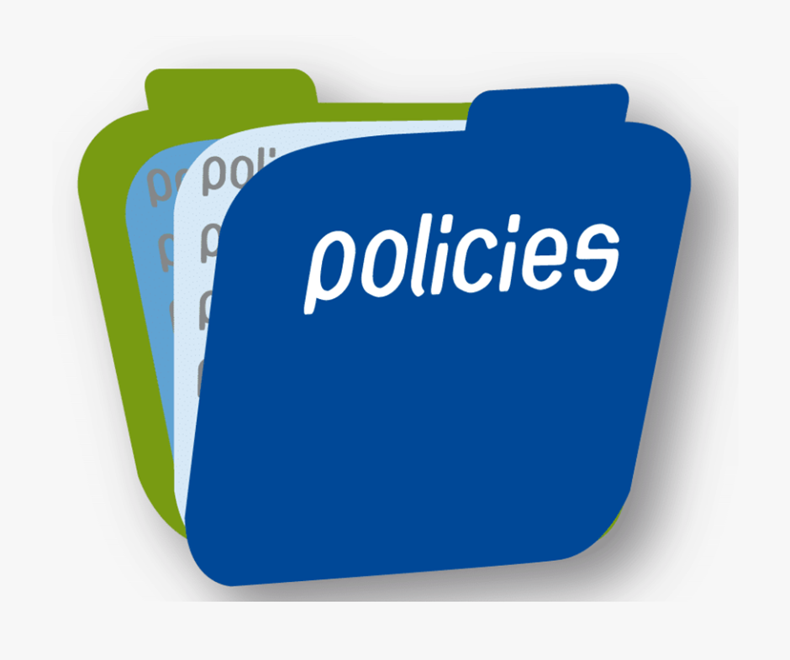

Table of Contents

Who we are 4

What information do we collect from you? 5

Why do we collect this information? 6

What information about you do we obtain from others? 8

Healthcare Service Providers 8

Grant Applications 8

Where did we get this information? 8

Healthcare Service Providers 8

Grant Applications 8

Who might we share this information with? 9

Disclosure of your information 9

How long do we keep hold of your information? 10

Transfer of your information outside the Eurpoean Union or the European Economic area? 10

What are your rights with respect to your information? 11

What will happen if we change our privacy notice? 12

Cookies 13

How can you contact us? 13

# Who we are



We are the Health Research Board (‘HRB’), a statutory body which acts under the auspices of the Department of Health, with an address at Grattan House, 67-72 Lower Mount Street, Dublin 2, D02 H638.

We are the lead agency responsible for facilitating, supporting and funding health research in Ireland. Our other role is to assist the Department of Health in its planning for certain health care services.

This notice sets out the basis on which any personal data we collect from you, or that you provide to us, will be processed by us. Please read the following carefully to understand our practices regarding your personal data and how we will treat it.

We use certain expressions throughout this document such as **Personal data**. This means any information relating to an identified or identifiable natural person (‘data subject’); an identifiable natural person is one who can be identified, directly or indirectly, in particular by reference to an identifier such as a name, an identification number, location data, an online identifier or to one or more factors specific to the physical, physiological, genetic, mental, economic, cultural or social identity of that natural person;

**Special categories of Personal Data and Sensitive personal data** means information revealing racial or ethnic origin, political opinions, religious or philosophical beliefs, or trade union membership, and the processing of genetic data, biometric data for the purpose of uniquely identifying a natural person, data concerning health or data concerning a natural person’s sex life or sexual orientation.

For the purpose of the Data Protection Acts 1988 and 2003 (as amended) (the ‘DPA’) and from 25 May 2018, the General Data Protection Regulation (the ‘GDPR’), the data controller is the HRB.

# What information do we collect from you?



You may give us information by:

* corresponding with us by phone, e-mail or otherwise. We ask you to disclose only as much information as is necessary for the purpose of your interaction with us or when submitting a question/suggestion/comment in relation to our website or our services.
* applying to work with us as an employee or contractor or agreeing to act as a Reviewer for the assessment of grants on our behalf. The type of information you may provide includes your CV, a cover letter, your name, address, e-mail address and phone number. CVs should include information relevant to your employment history and education (degrees obtained, places worked, positions held, relevant awards, and so forth). We ask that you do not disclose sensitive personal information (e.g. gender, height, weight, medical information, religion, philosophical or political beliefs, financial data) in your application.
* you or your team applying for a research grant with us.
* Using our EU support service to identify opportunities for EU funding.
* using healthcare services and facilities in Ireland provided by the Health Service Executive and a number of independent healthcare service providers, in the treatment and provision of services in respect of drug and alcohol addiction, intellectual and physical disability and mental health.
* using our National Drugs Library service. Users are required to complete a form for the purposes of protecting copyrighted material and information collected includes name, address, phone number and e-mail address.

# Why do we collect this information?



We collect the information in order to comply with our statutory function as set out under S.I. No. 279/1986 and to operate our organisation, to distribute research grants, to improve our website, to recruit staff, to engage Peer Reviewers and contracted researchers. We will use this information:

* to liaise with you about projects that we are undertaking with you;
* to carry out our obligations arising from any contracts entered into between you and us;
* to create a candidate profile for you;
* to communicate any upcoming HRB and relevant EU events; training initiatives or targeted funding opportunities;
* to assess a grant application that you submit to us and to distribute a grant where you are successful in your application to us;
* to support Irish researchers to engage in European and International research funding opportunities;
* to publish some basic information on your grant including applicant name, host institution, amount awarded and lay summary on our website;
* to generate general statistics around our current funding portfolio, and to evaluate our funding mechanisms and investment;
* to contact you with regard to monitoring of grant progress through written reporting and other means e.g. interim review. After your grant has ended we will continue to keep your information on file (in accordance with our retention policy) to allow us to evaluate the outcomes, outputs and impacts of HRB investment in your research;
* to help evaluate our career support and capacity building initiatives we will also use the information provided about people employed on awards;
* if you are a review panel member, with your express permission, we may contact you again in future regarding other review opportunities;
* to fulfil our statutory function which includes an obligation to maintain and develop Health Information Systems databases for healthcare research and planning purposes;
* to administer and improve our website and for internal operations, including troubleshooting, data analysis, testing, research, statistical and survey purposes. For further information please see our Cookie Policy on our website;
* as part of our efforts to keep our website safe and secure;
* to make suggestions and recommendations to you and other users of our website about services that may interest you or them.

The legal bases for the processing of your data are:

1. that you have provided consent for the processing for one or more specific purposes. For example, when you subscribe to our Ezine or website alerts or the assessment of a grant application which you submit to us; or when you use certain healthcare services and facilities in Ireland and you provide your consent on foot of a notification received from the healthcare service provider;
2. processing necessary for the performance of a contract which you have entered into with us or to take steps at your request prior to entering into a contract;
3. processing necessary for compliance with a legal obligation to which we are subject;
4. processing necessary is for the performance of a task in the public interest or in the exercise of official authority vested in us by virtue of our statutory functions as set out in SI No. 279/1986 and Section 2(b) of SI No. 305/2007.
5. Processing is necessary for archiving purposes in the public interest, scientific or historical research purposes or statistical purposes in accordance with [Article 89](https://gdpr-info.eu/art-89-gdpr/)(1) based on Union or Member State law which shall be proportionate to the aim pursued, respect the essence of the right to data protection and provide for suitable and specific measures to safeguard the fundamental rights and the interests of the data subject. We rely on this legal basis to process special categories of data in our work related to the treatment and provision of services in respect of drug and alcohol addiction, intellectual and physical disability and mental health.

# What information about you do we obtain from others?

## Healthcare Service Providers

In order to fulfil our statutory functions, when you use healthcare services and facilities in Ireland provided by the Health Service Executive and a number of independent healthcare service providers, for the treatment and provision of services in respect of drug and alcohol addiction, intellectual and physical disability and mental health, we obtain the following categories of personal data from others:

* Name and address;
* Date of birth;
* Occupation;
* Nationality and ethnicity;
* Diagnosis;
* Previous admissions;
* Treatment or services received;
* Discharge date;
* Condition at date of discharge;

## Grant Applications

Your research body/institution may provide us with your contact details and CV as part of a research grant application or as part of the grant monitoring and evaluation processes for successful grants.

# Where did we get this information?

## Healthcare Service Providers

We obtain this information from the Health Service Executive and other independent healthcare service providers from whom you are receiving treatment or services.

## Grant Applications

We obtain this information from you and your research body/institution as part of a research grant application submitted to us, or as part of progress reports, evaluation reports or other documents associated with the monitoring of your grant e.g. personnel information form.

If you are a peer reviewer, we obtain information about your area of expertise and contact details via openly accessible data sources via the internet.

# Who might we share this information with?



In order for us to fulfil our statutory function, we may share your personal data with selected third parties including:

* The **Health Service Executive**, the **Department of Health**, and the **European Medicines Agency**, in the performance of our statutory functions, the aims of which are to improve health and the effectiveness of health services in Ireland.
* **Government agencies** such as the Revenue Commissioners, Garda Síochana, or other agencies for the detection, investigation or prosecution of offences and to enable them to perform their functions. Please note that while managing the National Health Information Systems (‘NHIS’), the HRB will never share any personal data in this regard.
* **Peer reviewers**, selected for their specific expertise in relation to submitted applications, who can be based anywhere in the world.
* **Public reviewers** providing Public and Patient Involvement input into the grant review, who are typically based in Ireland but may be from elsewhere.
* **Funding agencies outside of Ireland**, such as the National Institutes of Health in the United States, in order for researchers based in Ireland to access funding/co-funding opportunities outside of Ireland.

# Disclosure of your information

We may also share your information with selected third parties including:

* Business partners, suppliers and sub-contractors for the performance of any contract we enter into with them or you and to assist us in fulfilling our statutory functions.

We have set out below a list of third parties with whom we share your data:

1. HSE, Department of Health and other government & European health agencies
2. Sub-contractors e.g. Peer and Public Reviewers
3. Cloud Service Providers
4. IT Back-up Providers
5. Archive/shredding companies
6. Email and IT service providers
7. Auditors
8. Accounting software
9. CCTV service providers
10. Security software
11. Cookie analytics service provider

# How long do we keep hold of your information?

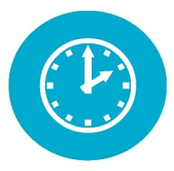

The time periods for which we retain your information depends on the type of information and the purposes for which we use it. We will keep your information for no longer than is required or permitted. For further information please see our Data Retention Policy on our website.

# Transfer of your information outside the European Union or the European Economic area?

* The following categories of data are **not transferred outside of the EU**: Health Information Systems data, HRB Human Resources data.
* In the context of research funding applications submitted to the HRB, your personal data may be shared by the HRB with **third parties outside of the EU**, e.g. for the purposes of international peer review in line with our statutory function. The Lead Applicant in funding applications will be asked to confirm that they are aware of this possibility at the time of application submission.
* In the context of research funding applications submitted by applicants to **funding agencies outside of Ireland**, such as the National Institutes of Health in the United States, in order for researchers based in Ireland to access HRB funding/co-funding. In such cases it may be necessary for HRB to share data such as the applicants name, institution, project title, funding requested with the NIH in order to confirm HRB support for the application.

# What are your rights with respect to your information?



You have the following rights:

* The right to access the information we hold about you.
* The right to require us to rectify any inaccurate information about you without undue delay.
* The right to have us erase any information we hold about you in circumstances such as where it is no longer necessary for us to hold the information for your use of our services or if you have withdrawn your consent to the processing.
* The right to object to us processing information about you such as processing for profiling or direct marketing.
* The right to ask us to provide your information to you in a portable format or, where technically feasible, for us to port that information to another provider provided it does not result in a disclosure of information relating to other people.
* The right to request a restriction of the processing of your information.

Where our processing of your information is based on your consent to that processing, you have the right to withdraw that consent at any time but any processing that we have carried out before you withdrew your consent remains lawful.

You may exercise any of the above rights by emailing [dpo@hrb.ie](mailto:dpo@hrb.ie) or writing to

DPO

Health Research Board,

Grattan House,

67-72 Lower Mount Street,

Dublin 2.

You may lodge a complaint with your local supervisory authority with respect to our processing of your information. In Ireland, the local Supervisory Authority is the Office of the Data Protection Commissioner with an address at

DATA PROTECTION COMMISSION

21 FITZWILLIAM SQUARE SOUTH

DUBLIN 2

D02 RD28

IRELAND

# What will happen if we change our privacy notice?



This notice may change from time to time, and any changes will be posted on our website and will be effective when posted. Please review this notice each time you use our website or our services. This notice was last updated on the date appearing on the cover hereof.

# Cookies

For details of cookies we use and how they are used, see our [Cookie Notice](https://www.hrb.ie/about/cookie-notice/)

# How can you contact us?



You can contact us by:

Phone: 01 2345000

Website: [www.hrb.ie](http://www.hrb.ie)

Email: dpo@hrb.ie

Post:

DPO

Health Research Board,

Grattan House,

67-72 Lower Mount Street,

Dublin 2.

**Version Control Sheet (VCS)**



|  |  |
| --- | --- |
| **Policy Title** | Privacy Notice |
| **Policy Owner**  **Name:**  **Job Title:** | DPO |
| **Business Area:** | Corporate Operations |
| **Date policy will take effect** | 24/06/2019 |

**Is this policy to be published on any of the HRB’s websites?** Yes / No

**Reason for publication:**

Information for grant holders/applicants

Requirement under legislation

Requirement under the Code of Practice for the Governance of State Bodies

|  |  |  |  |  |
| --- | --- | --- | --- | --- |
| **Website publication history** | | | | |
| **Date published** | **Version published** | **Website Publication authorised by: (name)** | **Website posting completed by** | **Location on website** |
| 24 June 2019 | V 2.0 | Martin Morgan | Ger Casey | https://www.hrb.ie/about/privacy-notice/ |
|  |  |  |  |  |
|  |  |  |  |  |

|  |  |  |  |
| --- | --- | --- | --- |
| **Version Control** | | | |
| **Version** | **Name** | **Date** | **Changes** |
| 1.1 | Liam Sinnott | June 2019 | Document reformatted |
| 1.2 | Martin Morgan | June 2019 | Reviewed |
| 2.0 | ET | 24/06/2019 | Approved |
| 2.1 | Liam Sinnott | 16/11/2021 | Legal Basis Added.  Section added for “Transfer of your information outside the European Union”  Data Protection Commission’s details updated  Reference to our Cookie Policy added |
| 2.2 | Liam Sinnott | 23/11/21 | Changing name of policy to Privacy Notice |
| 3.0 | ET | 29/11/21 | Approved |